AWS IAM
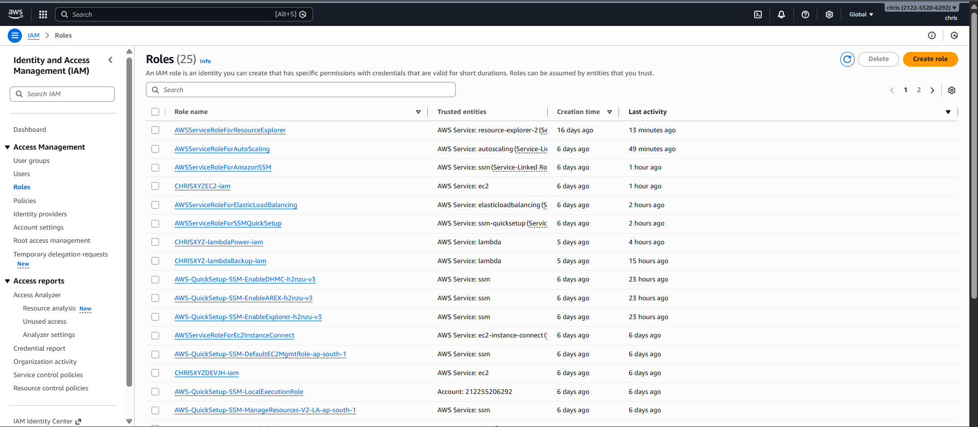
CHRISXYZEC2-iam & CHRISXYZDEVJH-iam : SSM access
CHRISXYZ-lambdaPower-iam & CHRISXYZ-lambdaBackup-iam : Custom policies attached for required EC2 access / S3 bucket access / AMI creation access.

